fetch dt.entity.aws_network_load_balancer

| fields arn, awsVpcName, entity.name

timeseries by:{dt.entity.host}, {

bytes_read=sum(dt.host.disk.bytes_read),

bytes_written=sum(dt.host.disk.bytes_written)

}

timeseries usage=avg(dt.host.cpu.usage),

filter: {in(

dt.entity.host,

classicEntitySelector("type(host),cpucores(\"2\")")

)}

| fieldsAdd valueAvg = arrayAvg(usage)

| fieldsRemove usage

fetch dt.davis.problems

| filter in(dt.entity.aws_network_load_balancer, "AWS_NETWORK_LOAD_BALANCER-551A03915062A757")

| fields event.name, event.description, dt.entity.aws_network_load_balancer, event.start, event.end, event.status

| fieldsAdd problemDurationMinutes = (coalesce(event.end, now()) - event.start) / 60000

| expand dt.entity.aws_network_load_balancer

| lookup [

fetch dt.entity.aws_network_load_balancer

| fields id, entity.name

], sourceField: dt.entity.aws_network_load_balancer, lookupField: id, prefix: "nlb."

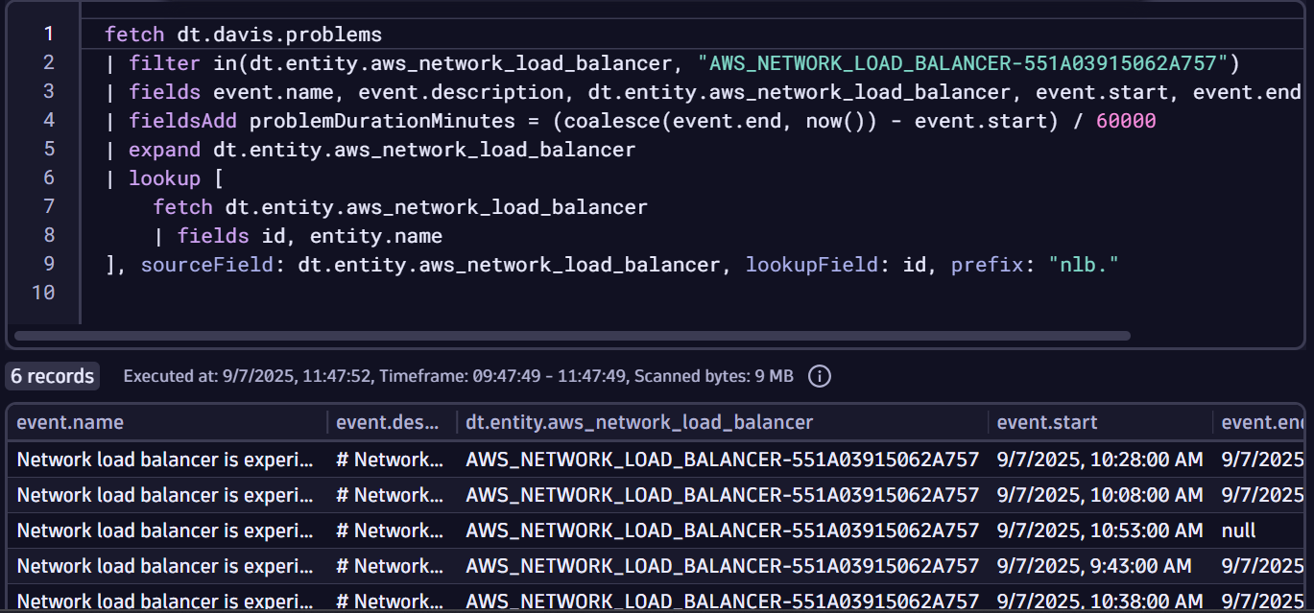

fetch dt.entity.service_instance

| lookup [ fetch dt.entity.host ],

sourceField: runs_on[dt.entity.host],

lookupField: id,

fields: { host = entity.name }

fetch bizevents, from: now() - 30m

| filter in(event.type, array("com.easytrade.long-sell", "com.easytrade.quick-sell"))

| summarize sum(amount), by:{accountId}

data record(content="117.16.75.9 GET//setup.php HTTP/1.1 404 474")

| parse content, "IPV4:IP SPACE LD:method'//'LD SPACE LD:HTTPVERSION SPACE INT:responsecode SPACE INT:responseothercode"